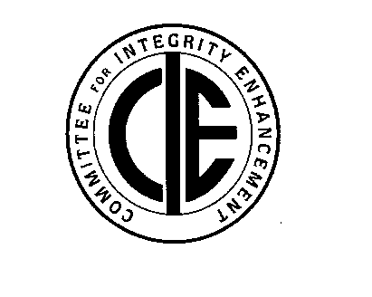
COMMITTEE
for INTEGRITY
ENHANCEMENT
P.O. Box 764
Muncie, IN 47308
ANNOUNCING THE
2020 PERSONAL INTEGRITY
AWARDS

The Committee for Integrity Enhancement seeks nominations for the 2020 Personal Integrity Award. Please help us identify a current Delaware County resident who has distinguished him or herself as a person of high principles and good character. Candidates should demonstrate core elements of integrity (honesty, fairness, caring and respect for others, responsible citizenship, accountability) throughout their daily lives and decision-making.

NOMINATING GUIDELINES

- A complete nomination includes all contact information, a description of the candidate’s qualifications, and at least two supporting references for additional endorsement.
- Candidates must be current residents of Delaware County.
- Nominations must be submitted online or postmarked by Saturday, February 1, 2020.
- Representatives from the Committee for Integrity Enhancement will contact all references for verification and review of the candidate’s qualifications.
- Recipient(s) of the Personal Integrity Award will be announced and recognized at an awards ceremony on Monday, April 13, 2020 at 6:30 pm at Central High School.

Name of Nominator (person completing form):____________________________________________
Address:_______________________________________________________ Phone:______________
Email address: ___________________________________________________
Name of Candidate for award:_________________________________________________________
Address:_______________________________________________________ Phone:______________
Email address: ___________________________________________________
Candidate’s qualifications (use space below or attach a one-page letter of endorsement):
__________________________________________________________________________________
__________________________________________________________________________________
__________________________________________________________________________________
__________________________________________________________________________________
__________________________________________________________________________________
__________________________________________________________________________________
__________________________________________________________________________________
Additional reference #1: Additional reference #2:
Name:___________________________________ Name:___________________________________
Phone:___________________________________ Phone:___________________________________
*** Return by February 1, 2020 to CIE, PO Box 764, Muncie, IN 47308***
Or complete online at www.integrityenhancement.com

